SEPTEMBER - Self-Esteem |  | OCTOBER - Sharing Our Lives
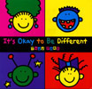 | It's Okay To Be Different by Todd Parr | 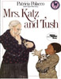 | Mrs Katz & Tush by Patricia Polacco
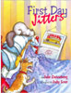 | First Day Jitters by Julie Danneberg and Judith DuFour Love | 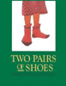 | Two Pairs of Shoes by Esther Sanderson
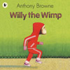 | Willy The Wimp by Anthony Browne | 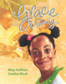 | Grace & Family by Mary Hoffman
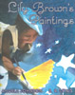 | Lily Brown's Paintings by Angela Johnson | 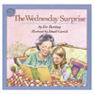 | The Wednesday Surprise by Eve Bunting
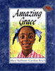 | Amazing Grace by Mary Hoffman | 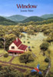 | Window by Jeannie Baker
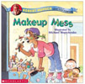 | Makeup Mess by Robert Munsch | 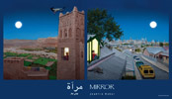 | Mirror by Jeannie Baker

NOVEMBER - Peace |  | DECEMBER - Building Supportive Communities
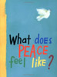 | What Does Peace Feel Like by Vladimir Radunsky | 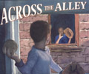 | Across The Alley by Richard Michaelson
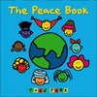 | The Peace Book by Todd Parr | 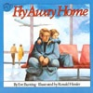 | Fly Away Home by Eve Bunting
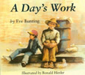 | A Day's Work by Eve Bunting | 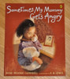 | Sometimes My Mommy Gets Angry by Bebe Moore Campbell
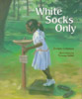 | White Socks Only by Evelyn Coleman | 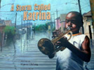 | A Storm Called Katrina by Myron Uhlberg
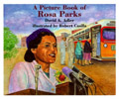 | A Picture Book of Rosa Parks by David A. Adler | 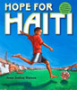 | Hope for Haiti by Jesse Joshua Watson
 |  | 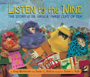 | Listen To The Wind by Greg Mortenson & Susan Roth

JANUARY - Rights of the Child |  | FEBRUARY - Caring Hands
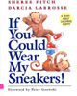 | If You Could Wear My Sneakers by Sheree Fitch | 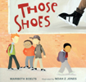 | Those Shoes by Maribeth Boelts
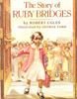 | The Story of Ruby Bridges by Robert Coles | 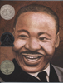 | Martin's Big Words by Doreen Rappaport
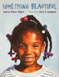 | Something Beautiful by Sharon Dennis Wyeth | 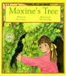 | Maxine's Tree by Diane Carmel Leger and Dar Churcher
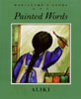 | Painted Words by Aliki | 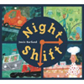 | Night Shift by Jessie Hartland
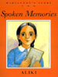 | Spoken Memories by Aliki | 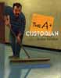 | The A+ Custodian by Louise Borden
 |  | 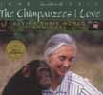 | The Chimpanzees I Love by Jane Goodall

MARCH - Untie the Knots of Prejudice |  | APRIL - Local and Global Citizenship
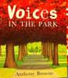 | Voices In The Park by Anthony Browne | 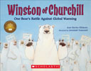 | Winston Of Churchill by Jean Davies Okimoto and Jeremiah Trammell
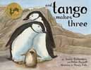 | ...And Tango Makes Three by Justin Richardson, Peter Parnell and Henry Cole | 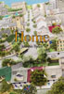 | Home by Jeannie Baker
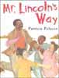 | Mr. Lincoln's Way by Patricia Polacco | 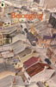 | Belonging by Jeannie Baker
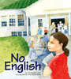 | No English by Jacqueline Jules | 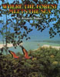 | Where The Forest Meets The Sea by Jeannie Baker
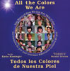 | All The Colors We Are by Katie Kissinger | 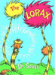 | The Lorax by Dr. Seuss
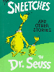 | The Sneetches by Dr. Seuss | 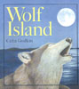 | Wolf Island by Celia Godkin
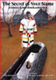 | The Secret of Your Name by David Bouchard | 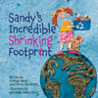 | Sandy's Incredible Shrinking Footprint by Femida Handy

MAY - True Worth and Beauty |  | JUNE - Circles and Cycles
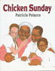 | Chicken Sunday by Patricia Polacco | 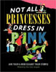 | Princess Grace by Mary Hoffman
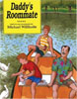 | Daddy's Roommate by Michael Willhoite | 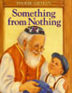 | Not All Princesses Dress In Pink by Jane Yolen
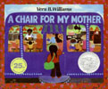 | A Chair For My Mother by Vera Williams | 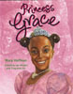 | Something From Nothing by Phoebe Gilman
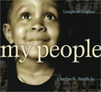 | My People (Langston Hughes Poem) picturebook by Charles R Smith Jr.

