Name: ______________________________ Class: __________ Date: _______________

Ms. Teschow's Hallowe'en Dilemma

Ms. Teschow is getting ready to throw a Hallowe’en party for her homeroom class. She has decided to distribute (healthy) treats to her students, and will place those treats in either cups or on plates. She has 2 packages of cups, and 3 packages of plates

Ms. Teschow has asked for your help setting up the party. Here is what she’d like you to do:

- Divide up the cups/plates onto trays (this will make it easier to hand out to the groups in class!)
- Each tray can contain only cups, OR plates
- There must be an equal number of cups or plates on each tray (it’s only fair!)
- There cannot be any cups or plates left over.

What is the largest number of cups (or plates) you could put on each tray? And how many trays will you need?

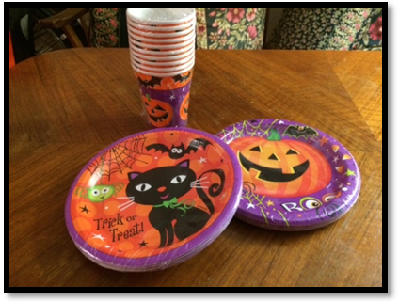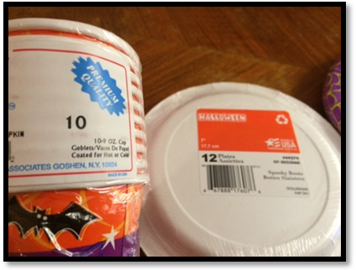

STEP 1 – Understand the problem

Re-read, think about and/or discuss the problem. What are you being asked to find out? What information are you given, and what information do you need?

STEP 2 – Make a Plan

How is this problem similar to other problems you have solved? What strategy or strategies might you use to solve the problem? Represent problem with model, diagram, table or equation.

(over -->)
STEP 3 – Carry Out the Plan

Follow the steps to solve the problem -- show all your work below. Check each step as you work; revise or apply different strategies as necessary.

STEP 4 – Check/Reflect

Reread the question and think about your answer. It is reasonable, and does it make sense? How do you know? Is your solution the most efficient one? Are there other possible solutions to this problem? How do you know? What extensions or variations can you think of?

CATEGORY | LEVEL 1 (D, 50-59%) | LEVEL 2 (C, 60-69%) | LEVEL 3 (B, 70-79%) | LEVEL 4 (A, 80-100%)
Mathematical Thinking | - demonstrates a limited understanding of the problem  - shows little/no evidence of plan  - uses a strategy and attempts to solve the problem but does not arrive at an answer | - demonstrates some understanding of the problem  - shows some evidence of a plan  - carries out the plan to some extent by using a strategy and develops a partial and/or incorrect solution | - demonstrates the expected level of understanding of the problem  - shows evidence of an appropriate plan  - carries out the plan effectively using an appropriate strategy and solving the problem | - demonstrates a thorough understanding of the problem  - shows evidence of a thorough plan  - shows flexibility and insight when carrying out the plan by trying and adapting when necessary one or more strategies to solve problem  - considers extensions or alternate solutions
Communi-cation | • provides a limited or inaccurate explanation /justification that lacks clarity or logical thought  • communicates with limited effectiveness (may include words, diagrams, symbols, and/or numbers) | • provides a partial explanation/justification that shows some clarity and logical thought  • communicates with some effectiveness (may include words, diagrams, symbols, and/or numbers) | - provides a complete, clear, and logical explanation/ justification  - communicates with considerable effectiveness  - reflects on solution with considerable effectiveness (e.g., by assessing the effectiveness of strategies and processes used, by proposing alternative approaches, by judging the reasonableness of results, by verifying solutions) | - provides a thorough, clear, and insightful explanation/ justification  - communicates with a high degree of effectiveness  - reflects on solution with a high degree of insight (e.g., by assessing the effectiveness of strategies and processes used, by proposing alternative approaches, by judging the reasonableness of results, by verifying solutions)

Student Work Assessment Rubric

Dear Family;

Today we worked on the attached math problem together. Students spent part of the period thinking about and discussing the problem with others at their table group, then they worked independently on solving the problem and reflecting.

We invite you to review this problem with your child over the coming days, and use the rubric at the bottom of the second page to help guide your conversation about strengths and gaps. (Feel free to circle or highlight statements that you and your child believe reflect her/his work on this problem.)

Once you have had a chance to review this work, please sign and date below, and feel free to provide any comments or feedback. We value your partnership in the math program! :)

_____________________________________ _____________________________________ _______________
Name Signature date

Strengths, next steps, or other general comments (optional): _____________________________________________________________

_________________________________________________________________________________________________________________________

_________________________________________________________________________________________________________________________

Dear Family;

Today we worked on the attached math problem together. Students spent part of the period thinking about and discussing the problem with others at their table group, then they worked independently on solving the problem and reflecting.

We invite you to review this problem with your child over the coming days, and use the rubric at the bottom of the second page to help guide your conversation about strengths and gaps. (Feel free to circle or highlight statements that you and your child believe reflect her/his work on this problem.)

Once you have had a chance to review this work, please sign and date below, and feel free to provide any comments or feedback. We value your partnership in the math program! :)

_____________________________________ _____________________________________ _______________
Name Signature date

Strengths, next steps, or other general comments (optional): _____________________________________________________________

_________________________________________________________________________________________________________________________

_________________________________________________________________________________________________________________________

