Name: ______________________________ Class: __________ Date: _______________

Intro to Geometry...
What do You Already Know?

1. Quadrilaterals: Fill in the blanks.

The class of shapes called _______________ has these properties: 4 straight sides, 2
pairs of _________ sides, and 4 right angles. Quadrilaterals (a class of shapes that includes ________________ ) also have 4 straight _________ , but only some quadrilaterals have 4 ___________ angles. So, having 4 right angles is a property of all rectangles, but not all quadrilaterals. If a _________________ has 4 right angles and 4 sides of equal length, it is called a _______________ . A ____________ is a special type of quadrilateral.

2. Comparing Shapes

a) Copy this shape:

b) Now draw a shape that is different from the shape in one way, but the same in another way. How are they alike? How are they different?

over --->

3. Vocabulary
(For each of the following words, check the most appropriate box.)

Word | Never heard  of it | Heard of the word, but not sure what it means | Know the word | Know the word and can use it accurately to describe my thinking in math
quadrilateral
parallel
transversal
interior angle
complementary angle
right triangle
pythagorean relationship
vertices
polydron
polyhedron
platonic solid

4. Shape Examination
Tell how many faces, edges and vertices each of the following shapes has:

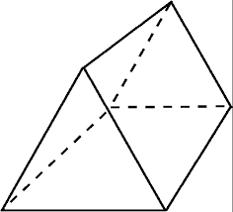

# of faces: ______ # of faces: ______

# of edges: ______ # of edges: ______

# of vertices: ________ # of vertices: ________

5. Angle Matching
Match the measurement to the most correct angle.

- 45º 1)

- 90º 2)

- 120 º 3)

- 175 º 4)

- 300 º 5)

6. Using a protractor

- What is the measurement of the following angle?

- Draw a 165 º angle below.

