Name: ______________________ Class: __________ Date: ___________________

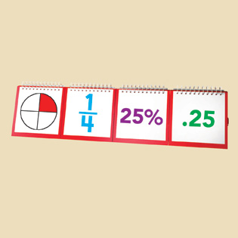
Fractions, Decimals & Percents:
Digital Porfolio

We are nearing the end of our Fractions unit. You have had several opportunities to show what you know, but there may be some success criteria which you have not yet demonstrated, or which you could demonstrate to a higher degree.

This is your chance to prove to Ms. Teschow that you understand, know and can "do" the things on the Success Criteria list. You will demonstrate your knowledge and understanding by creating a digital portfolio. You may use your own device, or borrow a school laptop.

You will be given 3-4 in class periods to work on this assignment. All work must be completed in class. (Please resist the temptation to work on this at home with help from outside sources. Ms Teschow wants to see what YOU know, not what Mom, Dad, Auntie, Grandpa, older sister, cousin, etc. know!!!)

STEP 1 - Success Criteria

Take a moment to review the learning goal and success criteria for your grade. Choose up to three criteria you still need to demonstrate (or want to show improvement on), and copy them into the chart below. Include both the criteria numbers and the actual criteria.
# | Criteria | beginning to demonstrate | accurately or almost accurately demonstrated | demonstrated with a high degree of accuracy, clarity, precision & insight

(over -->)

STEP 2 - Make Sure You Know

Look at the criteria listed. Do you know and understand them now? If not, what can you do to ensure you understand what you need to?

Choose and complete at least one of the following:

- Revisit Center ____ to review ________________________________________
- Look up ____________________________ in the text, and complete at least 2 practice questions
- Visit the homework help website and ask about ______________________________________
- I understand these criteria. I will explain them to ____________________ to check my understanding

STEP 3 - Choose A Format

Now it's time to demonstrate your understanding. Choose ONE of the following formats to show what you know:

Concept Map:
Use Smart Ideas, Idea Sketch or some other mind mapping app or software to create a concept map that clearly communicates your understanding of the criteria you selected. Your concept map should use relevant vocabulary and linking words, and should show relationships between and amongst the concepts learned in this unit. Feel free to also include photos or other images that help demonstrate your understanding.

Whiteboard Lesson:
Use Educreations, Explain Everything or Flipagram to "teach" a lesson on the concepts in your criteria. Your lesson should include writing or audio narration to explain the concept(s) you want to show your understanding of.

Puppet Show:
Use Puppet Pals, Sock Puppet or some other relevant software to create a short puppet show video that demonstrates your understanding. The emphasis should be on explaining your criteria - use the drama format to enhance your presentation, but don't get carried away with the plot line and characters!

STEP 4 - Revise and Edit

Have a look over your work through the eyes of a teacher. Have you used relevant math vocabulary to explain your thinking? Do your visuals enhance the criteria you are trying to demonstrate? Is your work accurate, clear and complete?

Make changes as needed, then email your final product to vera.teschow@peelsb.com -- BE SURE TO INCLUDE YOUR HOMEROOM IN THE SUBJECT LINE!!!

Once you have submitted your assignment electronically, please highlight this sentence, and hand this page in to the IN box so that Ms. Teschow knows you are finished. Thank you!

