Lesson 6 – Grade 8: Scatterplots, Histograms, Charts & Tables

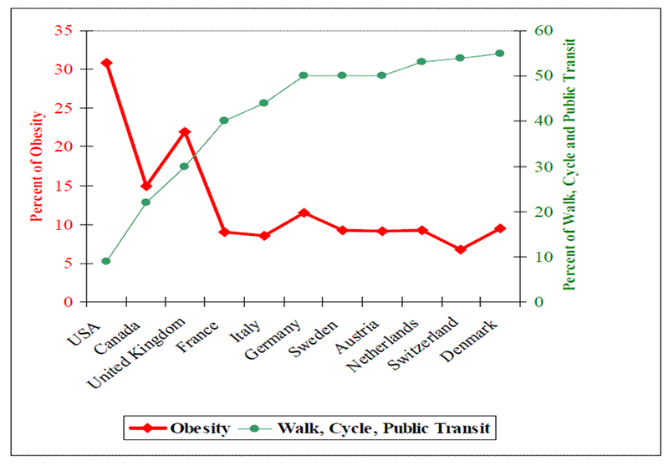
Source: http://bic.asn.au/information-for-moving-people/health-and-public-transport

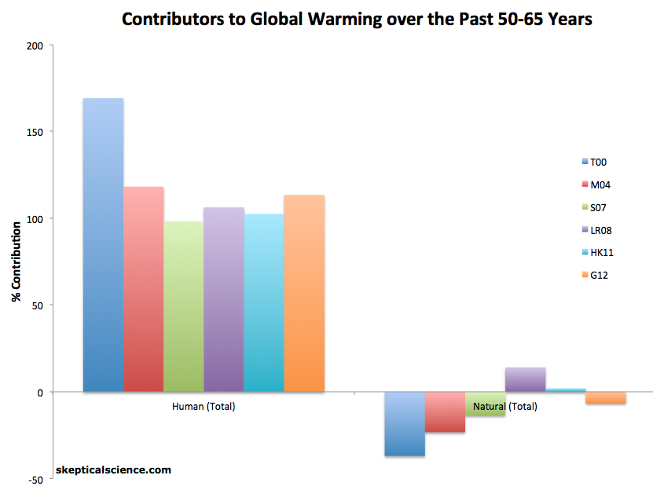
Source: http://climatesight.org/tag/ipcc/
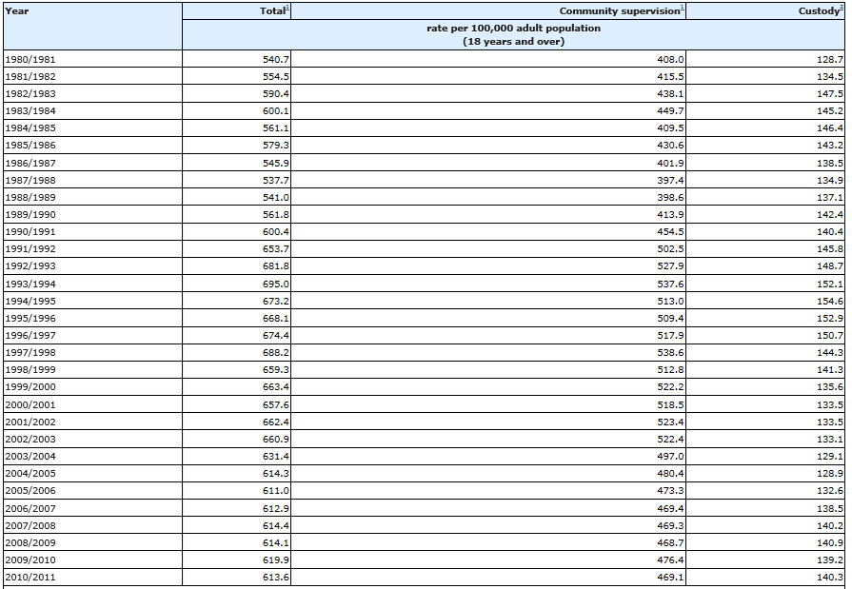
Average counts of adults under community supervision and in custody, Canada, 1980/1981 to 2010/2011

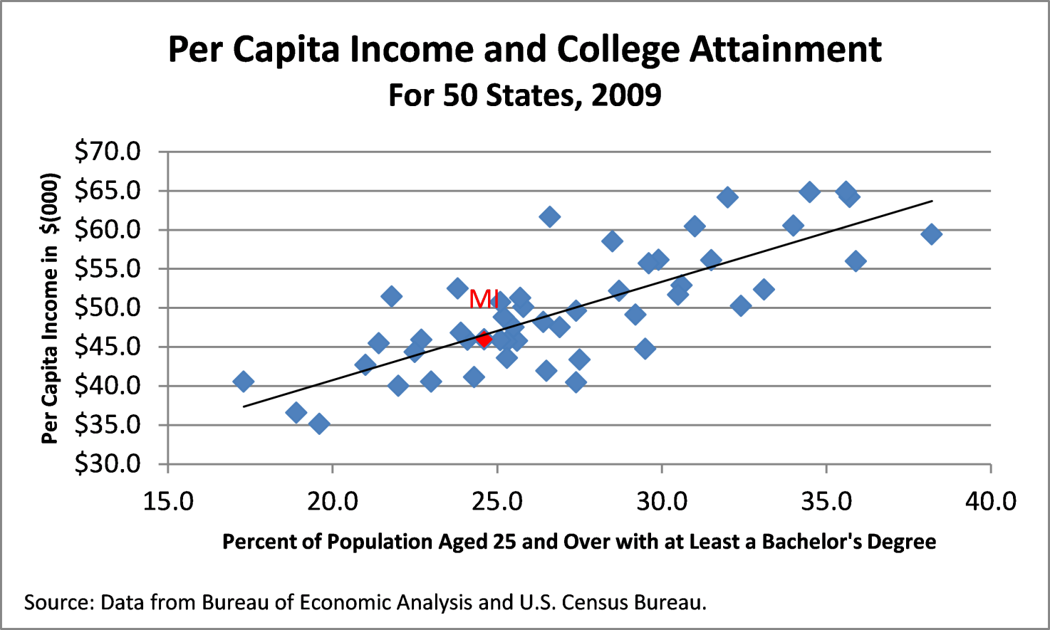

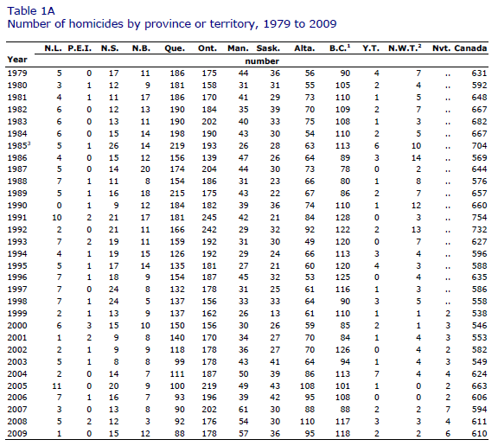

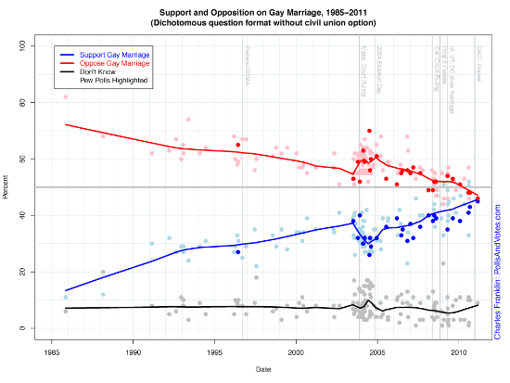
US Data, Source: http://big.assets.huffingtonpost.com/gaymarriage
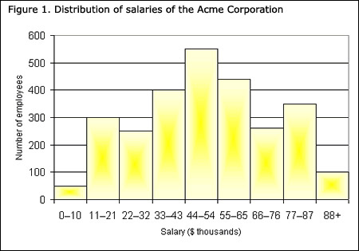

http://www.statcan.gc.ca/edu/power-pouvoir/ch9/histo/5214822-eng.htm

Correlation of Height and Arm Span

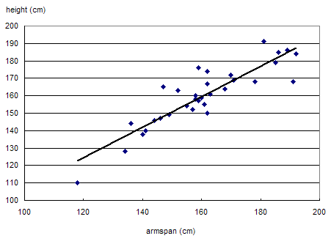

Source: http://www.statcan.gc.ca/pub/12-593-x/2010001/figures/figure9-eng.gif

Homeless Data

- http://www.covenanthousetoronto.ca/homeless-youth/facts-and-stats (great website with TONNES of stats and figures…non as graphs or tables, but an interesting read)
- http://www.cbc.ca/news/business/canada-falling-behind-on-poverty-inequality-says-report-1.1332406 (an interest-only article for students to read to better understand homelessness…not directly linked to math)

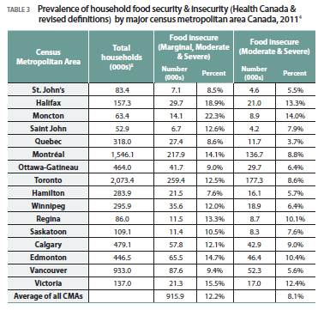
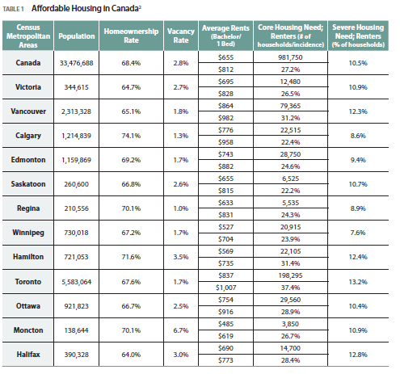

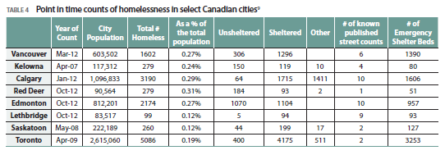

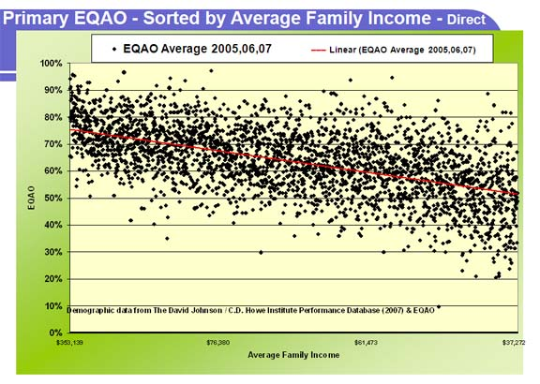

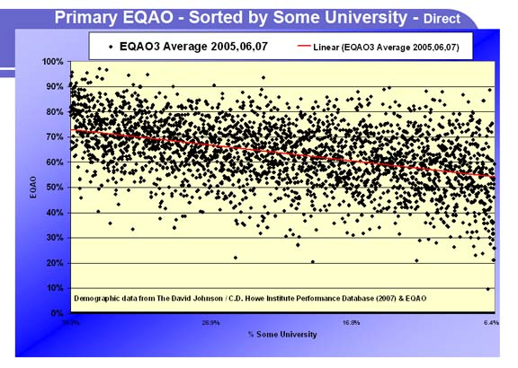

Source : http://www.eqao.com/emagazine/2008/05/eMagArticle.aspx?Lang=E&ArticleID=08&ItemID=23

