Lesson 6 – Grade 7: Circle Graphs, Double Line Graphs, Charts & Tables

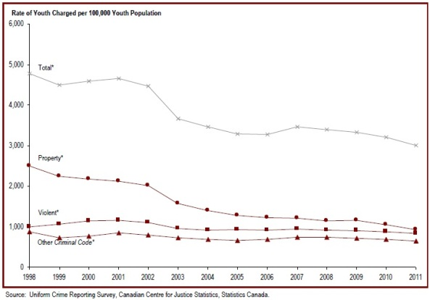

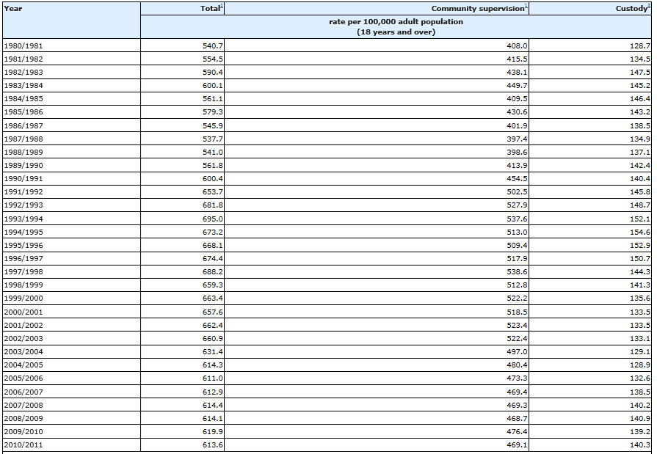
Average counts of adults under community supervision and in custody, Canada, 1980/1981 to 2010/2011

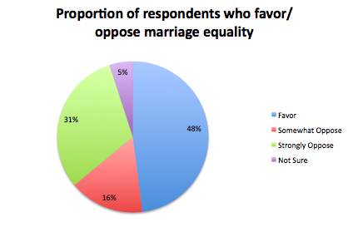

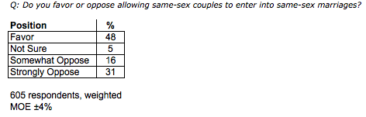

Source: http://www.dailykos.com/story/2011/02/09/942203/-New-Poll-Finds-Delaware-Supports-Marriage-Equality#
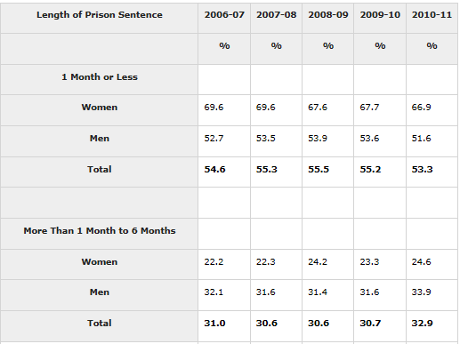

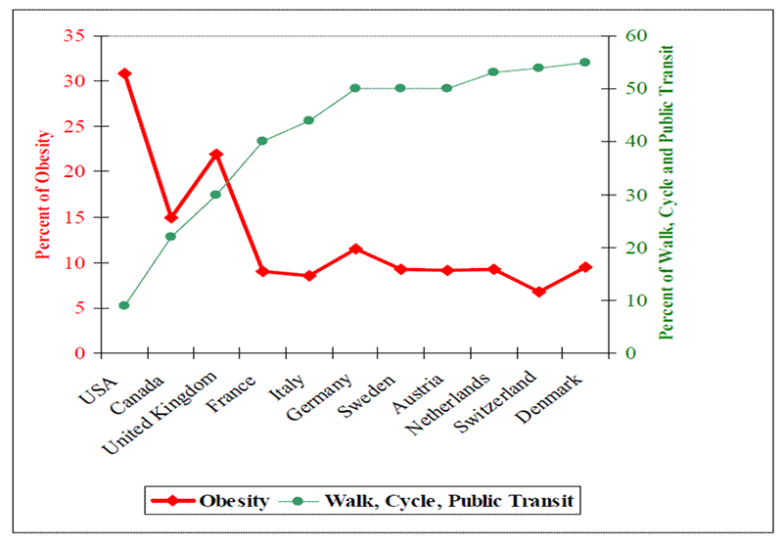
Source: http://bic.asn.au/information-for-moving-people/health-and-public-transport

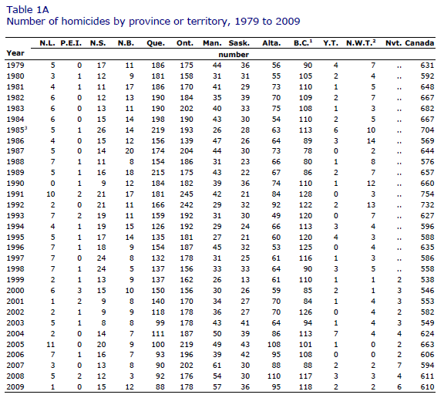

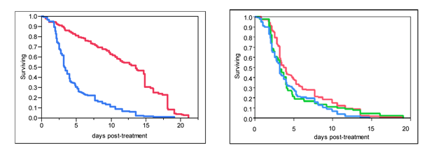
Figure1. Left: IAPV kills bees. Bees kept in cages and fed plain sugar syrup (red line) survived longer than bees fed sugar syrup plus IAPV (blue). Right: After inoculating bees with IAPV in sugar syrup, bees from two hives established from crosses between susceptible sources (green and blue) died faster than bees from the resistant x resistant cross (red).

Source: http://www.extension.org/pages/61384/an-update-on-bee-breeding-efforts-in-indiana:-breeding-for-resistance-to-israeli-acute-paralysis-vir#.VNPo201OWM8

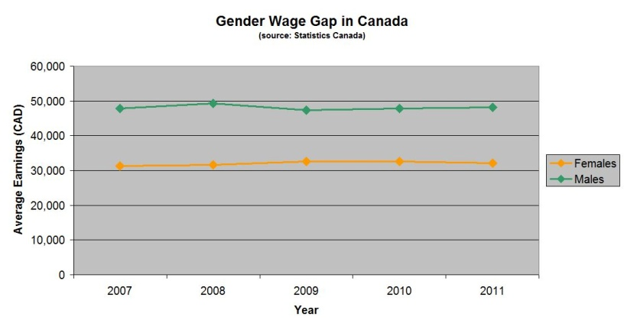

Homeless Data

- http://www.covenanthousetoronto.ca/homeless-youth/facts-and-stats (great website with TONNES of stats and figures…non as graphs or tables, but an interesting read)
- http://www.cbc.ca/news/business/canada-falling-behind-on-poverty-inequality-says-report-1.1332406 (an interest-only article for students to read to better understand homelessness…not directly linked to math)

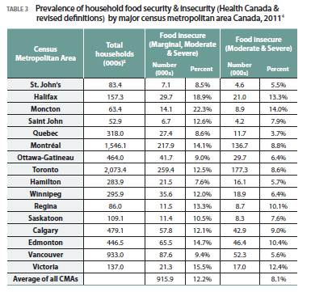
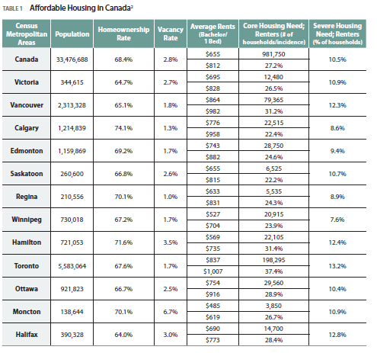
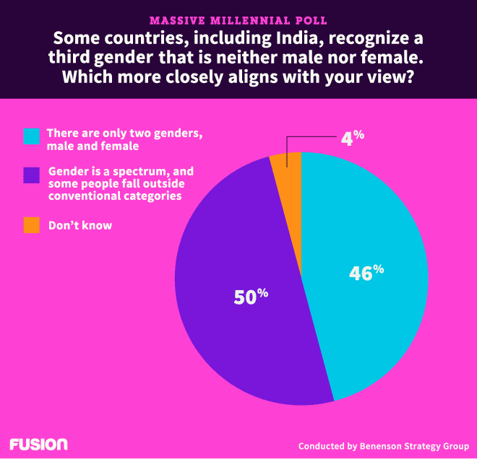
Source: http://fusion.net/story/42216/half-of-young-people-believe-gender-isnt-limited-to-male-and-female/

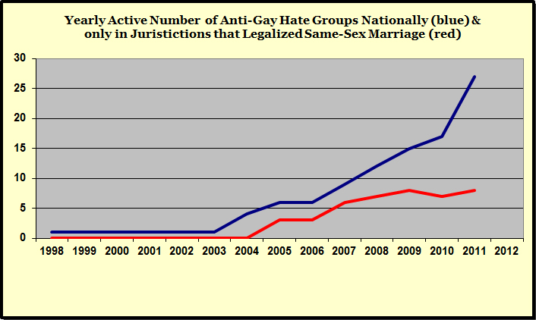
Source : http://www.dailykos.com/story/2012/09/30/1137309/-The-LGBT-Civil-Rights-Backlash-with-graphs

