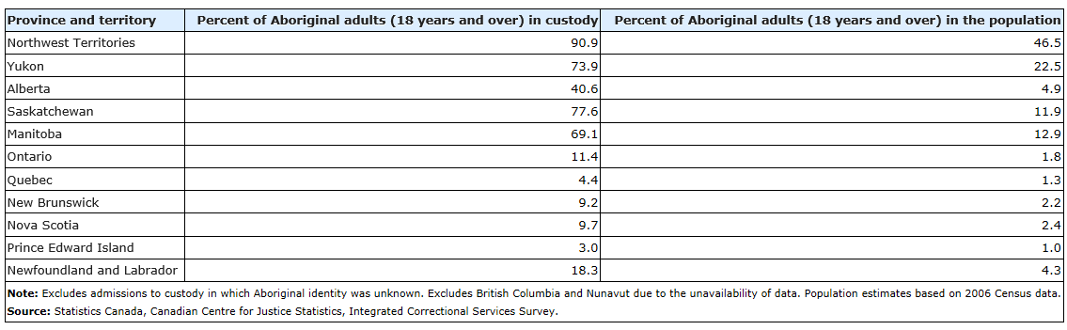
Length of Prison Sentences for Men and Women

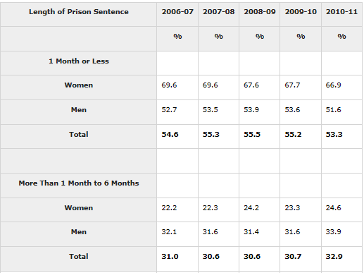

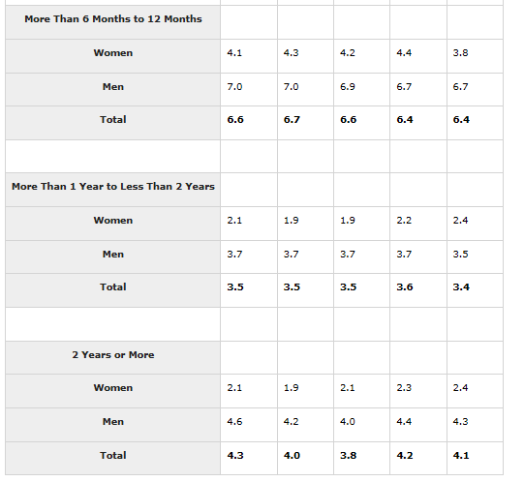

Incarceration Rates Around the World (per 100 000)

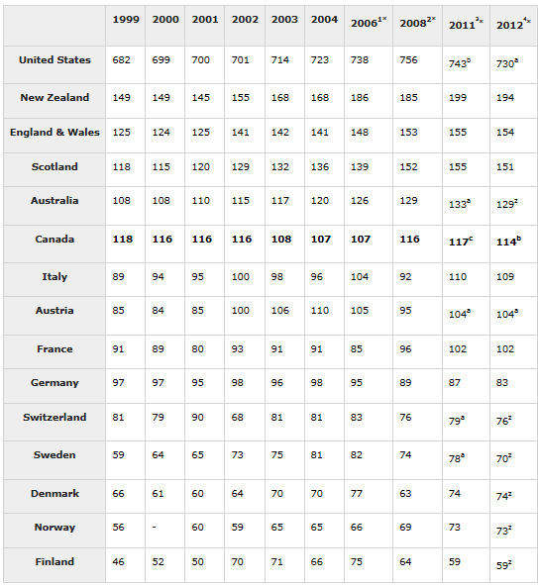

Raw Data Comparing Aboriginal Canadian and African American Situations

Canadian Median Income Aboriginal - $18,080
Canadian Median Income All – $68,410
American Median Income Black – $38,401

American Unemployment Rate Black – 12.6%
Canadian Unemployment Rate All – 6.9%
Canadian Unemployment Rate Aboriginal – 13.9%

Canadian Dropout Rate All – 8.5%
Canadian Dropout Rate Aboriginal – 22.5%
American Unemployment Rate Black – 10.7%

Canada Infant Mortality Rate All – 4.8%
Canada Infant Mortality Rate Aboriginal – 10.2%
American Infant Mortality Rate Black – 12.4%

