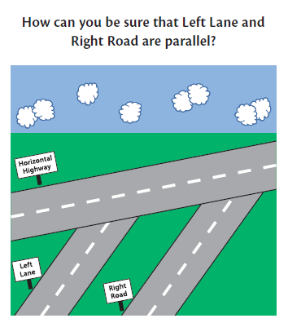

Math Centre #8
Math Journal
Materials:
- pencil & math notebook or blog
- image

Instructions:
- Write today’s date and the title “Math Journal Entry: Understanding Lines”. Underline the title neatly.

- Answer the question above. Write in complete sentences, and remember to use:
- Relevant math vocabulary (parallel, perpendicular, bisect, etc.)
- Examples to illustrate what you are writing about
- Pictures, numbers, maybe even labelled diagrams
- Strategies you used
- Questions you may still have

- If you get stuck, there is a “Journal Clues” poster at the station. Each clue is covered up by a sticky. If you’re not sure how to get started, feel free to look at a clue!

- Still not sure? Why not check out another clue, and discuss what you’ve read with a partner?

- When you have completed your journal entry, reread it to make sure it makes sense and could be understood if someone else read it.

- Read it once more to ensure you have used capitals and punctuation where needed. Make any changes as necessary.

- Tidy up the materials at your centre, thank any partners you may have discussed your journal with, and move to the net centre.

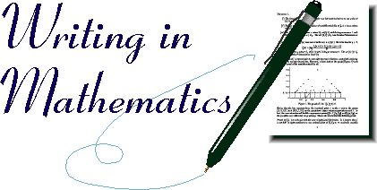

Centre 4 – Clues for Road Picture

Clue #1  Intersecting lines are NOT parallel. They meet at a single point. The distance between the line increases as you move from that point.  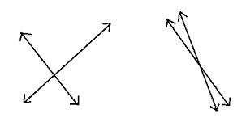 | Clue #2  Parallel lines do not meet. The distance between parallel lines remains constant.  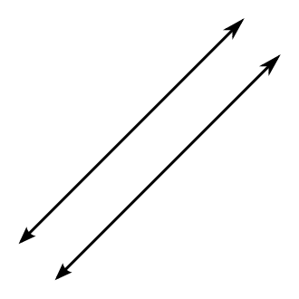
Clue #3  Two lines are perpendicular if they meet (“intersect”) at a right angle. That’s a 90º angle! | Clue #4  If you draw a perpendicular bisector through one line, and it’s STILL perpendicular when it goes through another line, those two lines MUST be parallel!  The bisector is the thing doing the “cutting”!
Clue #5  Lines, line segments, and rays can be parallel or the can intersect. Parallel lines, line segments, and rays never meet, as they remain a constant distance apart.  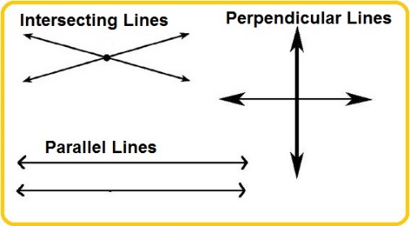 | Clue #6  If you draw a bisector through two parallel lines, corresponding angles will be congruent.  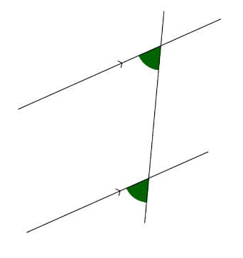  Bisector

