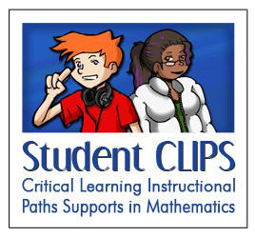
Math Centre #3 - Grade 7
CLIPS (max. 2 people per device)
Materials:
- pencil & math notebook
- flash-enabled device & headphones
- internet access
Instructions:
- Write today's date and the title "Math Clips". Underline the title neatly. Also record the name of your math partner for this activity.

- Visit the CLIPS website at www.mathclips.ca -- select the "Fractions - Exploring Part/Whole Relationships" cluster.
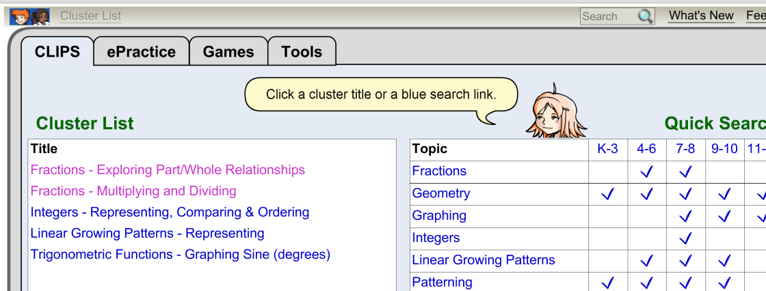
- Watch the video at the beginning of your cluster. Discuss the video with your partner. What math concepts does the video show?

- Choose a CLIP, and record the title. Then begin working through the activities for that clip. Stop and review activities as needed.

- After completing all the activities, choose one of the "Show What You Know" activities at the end of your clip. This activity should be done independently, and submitted to Ms. Teschow. You may print or take a screen shot, and glue or otherwise record it in your math notebook.

- Remember to log off when you are finished.

Math Centre #3 - GRADE 8
CLIPS (max. 2 people per device)
Materials:
- pencil & math notebook
- flash-enabled device & headphones
  - internet access
Instructions:
- Write today's date and the title "Math Clips". Underline the title neatly. Also record the name of your math partner for this activity.

- Visit the CLIPS website at www.mathclips.ca -- select the "Fractions - Multiplying and Dividing" cluster.

- Review the demo and try a few practice sessions, then play the "Solitaire Pyramid" game.

- If you are finding it too hard, please exit the cluster, and try a few activities from the "Fractions - Exploring Part/Whole Relationships" Cluster instead. (You can always come back to the other cluster later, or do it for homework!)

- Remember to log off when you are finished.

