Lesson 1 homework

Name: ____________________________ date: ____________________ class: 810
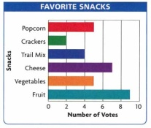
Data Management Homework

Choose ONE of the following activities to complete:

- Look up three “new” Data Management words from our list on Math is Fun, Brain Pop or some other reputable student math site - watch videos and complete follow up activities (take notes on your homework page)

OR...

- Find 3 data displays (could be online, mag., newspaper, etc.) -- include one histogram, one scatter plot and one graph of your choice

  - what do they show?
  - What might this data be used for?

Bring your homework with you, and be prepared to share next class!!!

Lesson 1 homework

Name: ____________________________ date: ____________________ class: 810
Data Management Homework

Choose ONE of the following activities to complete:

- Look up three “new” Data Management words from our list on Math is Fun, Brain Pop or some other reputable student math site - watch videos and complete follow up activities (take notes on your homework page)

OR...

- Find 3 data displays (could be online, mag., newspaper, etc.) -- include one histogram, one scatter plot and one graph of your choice

  - what do they show?
  - What might this data be used for?

Bring your homework with you, and be prepared to share next class!!!

